**Tags in Cucumber :**

**What are tags**

**How to use Tags**

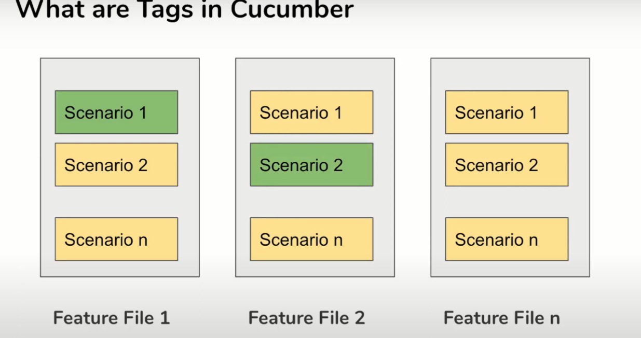

Features and Scenarios can be marked with Tags

Tags use @ symbol with some text e.g @Smoke Test

In the test runner we can run specific tags

A feature can have multiple tags

@smoke@regression@functional

Feature: verify login

Here we have used three tags

We can run with single or multiple tags using And / OR

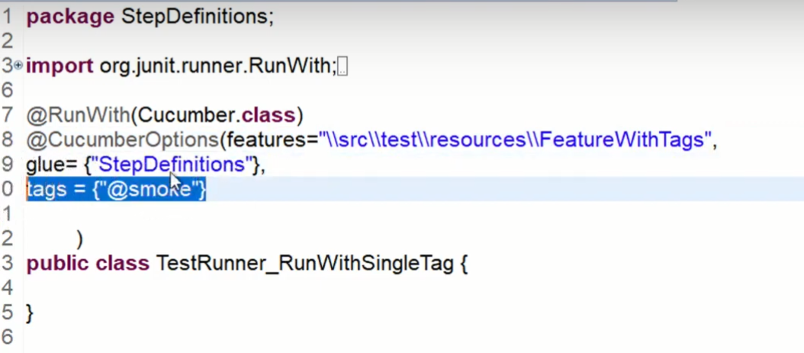

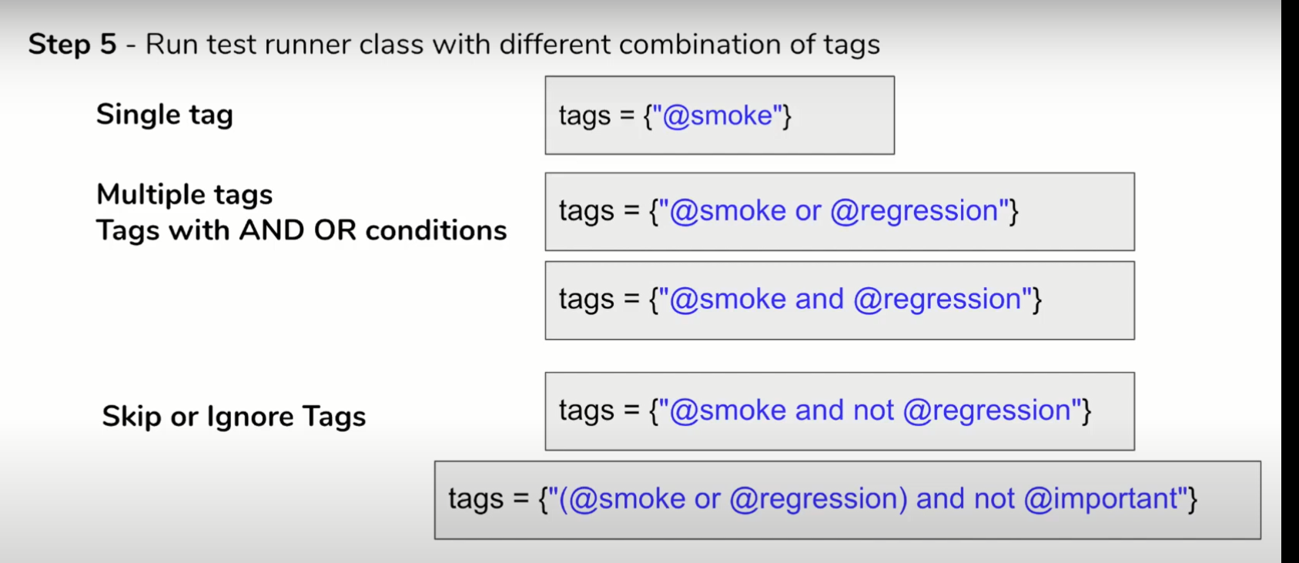

Tags can be placed above the following Gherkin Elements

Feature

Scenario

Scenario Outline

Examples

Note : It is not possible to place tags above Background or steps

(Given, When , Then , And and But )

Tags inherited

If you place tags above the feature file , it will be inherited by Scenario , Scenario Outline ,Examples .

You can create and keep ready multiple Test Runner classes with different combinations of Tags.

Or

Create commands with tags combination as required to be run from the command line.

**Hooks in Cucumber :**

1.What are Hooks ?

2.Why to use Hooks ?

3.When to use Hooks?

4.How to create & use Hooks – step by step Demo

5.Conditional Hooks

Scenario

Open the browser

Check with login credentials

Close the browser

Check with invalid Credentials

Setup and teardown – which are common steps for every scenario

@Before

@After

Hooks are functions or blocks of code which runs after and before , Hooks are just like annotations in testNG

**Scenario Hooks** : Runs before and after each scenario

**Step Hooks** : runs before and after each step

**Conditional Hooks : associate hooks with tags for conditional execution**

**Why to use Hooks**

To manage setup and teardown

To avoiding rewriting the common stepup or tear down actions

Allow better management of code workflow

**When to use Hooks**

Whenever you have some common setup and tear down actions to be executed before each scenario

How to use Hooks

